Test Pattern Reduction Using Various ML Algorithms

Anirudhra C S, Sujith Kumar Reddy B, Himavanth Ravindran Kammari, Vattikuti Bhanu Sahithya, Anita J P
Department of Electronics and Communication Engineering,
Amrita School of Engineering, Coimbatore,
Amrita Vishwa Vidyapeetham, India.
jp_anita@cb.amrita.edu

Abstract— This paper presents the integration of using ML models with fault simulation to reduce the test volume in VLSI testing. It introduces a novel approach to VLSI testing, focusing on reducing the test volume while maintaining high test coverage. It has an upper edge when compared with the traditional testing as the test cost reduces drastically. Experimental results show an average of 30% test pattern reduction is possible
Keywords—Automatic Test Pattern Generation (ATPG), Machine Learning (ML), Test Cost, Test Volume.
- INTRODUCTION
VLSI testing is a crucial part of the semiconductor industry. The purpose of this testing is to make sure that the manufactured chips or integrated circuits (ICs) meet their intended specifications and are free from any faults. The testing process is essential because even minor defects or faults in a VLSI chip can lead to significant malfunction or failure in the final product. Also, it brings a bad name to the company once when the semiconductor company recalls its chips back due to its faulty nature. This can result in significant losses for both the manufacturer and the end-user.

There are several reasons why VLSI testing is essential. Firstly, ICs are complex and contain billions of transistors and other components. It is practically impossible to verify every single transistor and connection on the chip. As a result, there is always the possibility of errors or faults in the design, manufacturing, or packaging of the IC. Testing at each stage helps to identify and diagnose these faults so that they can be corrected at that level.
Secondly, ICs are manufactured using complex processes that can itself introduce a range of defects. These include issues with lithography, doping, and metallization, etc. Testing can help to predict these defects before the ICs are sold to the costumers.
Thirdly, given that ICs are often used in critical applications, such as in medical devices, aerospace, and automotive systems, where even a minor malfunction can have serious consequences. VLSI testing helps to ensure that the ICs are reliable and meet their intended specifications. It also helps to ensure that the ICs meet the required performance and reliability standards.

Finally, VLSI testing can help in reducing the overall cost of manufacturing ICs. the faults that are detected in later stages, increases the cost in rectifying the errors. Hence it is necessary that VLSI testing is carried out each stage. By identifying and correcting faults early in the design or manufacturing process, manufacturers can avoid costly rework or recalls later. This can help to improve the yield and profitability of the manufacturing process.

Overall, VLSI testing is an important process in the ASIC design flow ensuring the quality, reliability, and performance of ICs. It helps to identify and diagnose faults in the design, manufacturing, or packaging process, and ensures that the ICs meet their intended specifications. VLSI testing is a complex and challenging task, but it is essential to the success of the semiconductor industry.
Traditional testing approaches in VLSI are becoming less advisable due to the increasing complexity and scale of Integrated circuits. These methods suffer from limitations such as excessive test volume, long test times, and high-test costs.
With modern VLSI designs, these traditional techniques are inadequate in addressing the challenges of power consumption, test application time, and test data volume. Therefore, innovative, and efficient testing methodologies are needed to overcome these limitations and ensure effective testing of complex VLSI designs. This paper is organized as follows: section gives an Introduction about VLSI testing. Related works are discussed in section II and different algorithms used in this project is discussed in section III. Section IV highlights the proposed methodology. Results are drawn in section V and the conclusion is summarized in VI.

Related work
The paper [1] proposes two fault injection methods for the Maximally Redundant Signed Digit Adder (MRSD) circuits: simulation-based and demux-based. The study shows that these methods can detect all feasible fault occurrences with increased speed. However, the randomized approach used in the technique may be computationally expensive and require significant computational resources, which could limit its practicality in some applications. The paper [2] proposes a method to minimize power consumption at the logic level using ISCAS85 circuits through pattern compaction and reordering. It uses Hamming distance-based ordering and filling don't care bits to reduce power consumption. However, it highlights that test vector compression can lead to loss of test coverage and reduced fault coverage and can increase test time due to the complexity of the compression algorithm. The paper [3] presents test data compression techniques using Circular Scan Architecture (CSA) to reduce test cost. The approach uses self-testing, circular scan, and test vector reordering to minimize the amount of test data volume. The technique employs different modes, such as broadcast mode and one bit update mode, to reduce test data volume and minimize conflicting bits and uses a test vector reordering strategy to decrease test data volume.

The proposed dynamic test pattern reordering strategy in [4] aims to maximize failing data and reduce test time using the kNN algorithm. It suggests which test patterns should be used for a failing chip, resulting in a 35% reduction in test time and increased failure data. However, it requires significant computational resources to analyze the results of previous tests and generate the next set of test patterns, which could limit its practicality in some applications. The paper [5] proposes a technique called Virtual Chain Partition (VCP) for reducing test time, data volume, and power consumption in digital circuits. VCP partitions the scan chain into multiple virtual chains based on specific criteria and assigns a different test pattern to each. Experimental results demonstrate that VCP is effective in reducing test time, data volume, and power consumption compared to traditional scan-based testing methods. However, VCP requires additional hardware resources for implementing the VCPI architecture, which may increase the overall cost of the testing process.
The paper [6] proposes a cost-effective adaptive test approach using a combination of genetic algorithm and simulated annealing to reduce the number of test items required while maintaining accuracy. The approach is aimed at reducing testing costs, and the paper also discusses potential limitations and challenges. However, the accuracy of the test models used is crucial for optimal test item selection, and inaccurate models may result in suboptimal test selection.
In [7], a machine learning-based algorithm is proposed to reduce test cost and time for VLSI circuits using feature extraction, selection, and classification. It outperforms traditional compression methods in cost reduction and test quality but requires many trainings samples and is sensitive to initial feature selection. The algorithm is focused on cost reduction and may lead to reduced test effectiveness as it does not consider other important factors such as test quality or fault coverage.
A methodology that combines ATPG with test power reduction strategies is shown in [8]. It focuses on generating targeted test patterns and reducing power consumption. However, the power reduction strategies cannot be used for huge set of test patterns. Moreover, the paper [9] highlights the the issue of excessive power consumption during the testing phase of digital circuits. It introduces an algorithm to identify and fill don't-care conditions, which minimally impact circuit functionality but contribute to power usage. A multistage compression technique is introduced in [10], where the data is divided into stages and compression algorithms is applied at each stage. However, this method could be computationally more expensive. [11] addresses the limitations of general-purpose testing techniques and proposes methods to optimize testing based on specific application requirements. It discusses algorithms and strategies for identifying critical test scenarios and designing application-specific test patterns. In paper [12], design for testing involves adding extra hardware to a circuit to enhance fault detection, particularly for challenging-to-observe faults. This approach strategically inserts observation points within the circuit's high-observability regions, improving structural testing and fault coverage for both on-chip and off-chip components. However, the area overhead will increase. In [13], The paper introduces an adaptive strategy for system-level testing (SLT) in semiconductor manufacturing, leveraging risk tagging to lower DPPM. Nevertheless, it falls short in providing quantitative evidence and addressing potential limitations or hurdles. Paper [14] addresses the challenge of detecting malicious hardware Trojans in System-on-Chips (SoCs) by introducing a novel test generation method using reinforcement learning for delay-based analysis. Though this paper isn’t for VLSI testing. However, the method they used to generate the test patterns was worth mentioning. In [15] they addresses the complexity of modern VLSI designs in the context of 5G technology and introduces an efficient auto-correction algorithm for logic bugs, including gate replacement and inverter issues. The algorithm aims to reduce fixing time and circuit size while maintaining design quality, outperforming existing tools which is important in fault- correction process, a important process in fault-correction. Paper [16] explores the use of artificial neural networks (ANNs) trained on hard-to-detect faults data to improve automatic test pattern generation (ATPG) by minimizing backtracks, resulting in more efficient ATPG performance. However, a potential drawback of this method could be the need for a substantial amount of training data to effectively guide backtracing for various fault scenarios. Through paper [17] the challenge of limited data in integrated circuit logic diagnosis during large-scale production is addressed. They introduce a test-reordering method that enhances diagnosability, resulting in a 10.6% and 5.1% increase in perfectly diagnosed failing chips for two designs. Paper [18] introduces a cost-effective and low-risk test generation algorithm for analog devices using an Extreme Learning Machine (ELM). The algorithm efficiently classifies response space, maintains test precision with fewer impulse-response samples, and simplifies the test signal generator and structure, all of which are validated through experiments.Another data-based method using deep stacked-sparse autoencoder (SSAE) is introduced in paper [19] for testing digital circuits, specifically ALU circuits, achieving high fault coverage. The network used here automatically reduces dimensions and extracts features, demonstrating superior performance in circuit fault detection compared to traditional methods. In paper [20], a greedy algorithm is used for fault diagnosis. However, Greedy algorithms may not always find the globally optimal solution and can sometimes get stuck in locally optimal choices.

- ML MODELS USED

A brief information is given about each algorithm used in the methodology. They are KNN, LDA, SVM, mRMR, Naïve Bayes. We’ll look in detail about each algorithm.

A. K-Nearest Neighbors (KNN):
The KNN algorithm works by finding the k nearest neighbors to a given input data point based on some distance metric.
With the training set of test patterns a KNN model is built. This model is trained by computing the distance between each test pattern and the other test patterns in the training set. The distance metric used in KNN model is Euclidean distance.
Once the distances are computed, the KNN algorithm identifies the k nearest neighbors to each test pattern based on the distance metric.

B. Linear Discriminant Analysis (LDA):
LDA seeks to project the data onto a lower-dimensional subspace while preserving as much class discrimination information as possible. The mean and variance of each feature are computed for each class separately. With this information, two scatter matrices are created for the classes. One is the between-class matrix where differences between the means of the different classes are measured. The next matrix created is the within-class matrix which measures the variations within the feature in each class. The eigenvectors are sorted in descending order of their Eigen values.

C. Minimum Redundancy Maximum Relevance(MRMR):
The MRMR algorithm works by selecting a subset of the original test patterns that are most optimal in selecting the patterns that has for the faults in the circuit while minimizing redundancy between the selected patterns. The relevance and redundancy scores for each test patterns are calculated. Once these scores are calculated. A subset of the original test patterns that have the highest relevance scores and lowest redundancy scores are taken as the optimal set of test patterns.

D. Support Vectored Machine (SVM):
Firstly, the data set which has test patters as features and its faulty type for each pattern is produced. Then, feature scaling is used to ensure that all features have equal importance during training. Then the features are scaled to have zero mean and unit variance. The SVM model has two important parameters to be tuned for optimal performance. One is regularization parameter (C) and another is kernel parameter(gamma).
Then the SVM model is trained on the prepared dataset using an optimization algorithm that finds the hyperplane that best separates the different classes of test patterns. The main objective is to minimize the classification error of the test pattern while maximizing the margin between the hyperplane and the test pattern (data points) closer to the hyperplane.

E. Naïve Bayes:
The Naive Bayes model is trained on the prepared dataset using a training algorithm that estimates the prior probabilities and the conditional probabilities of the input features given each class label. Then this model is used to classify each test pattern in the dataset given. The test patterns with high confidence belonging to a particular class are selected as the reduced set of test patterns.
- METHODOLOGY
This section delineates the proposed methodology we have implemented for the test volume reduction for testing the digital circuits. In this section, we compare and analyze different ML algorithms that can be used for this test volume reduction. Also, at the end of this section, reasoning is provided for using ML algorithms than compared to the traditional architectures like BIST modelling which occupies more area and consumes power and time. The methodology is shown in fig 1.
In our experiment, the dataset we have created is in such a way that the columns symbolize the test patterns, and the rows symbolizes the fault they can detect. The proposed mainly consists of two parts: test pattern generation and usage supervised learning classifier for reduction of test patterns. Through the following subdivisions, we discuss the process in detail.
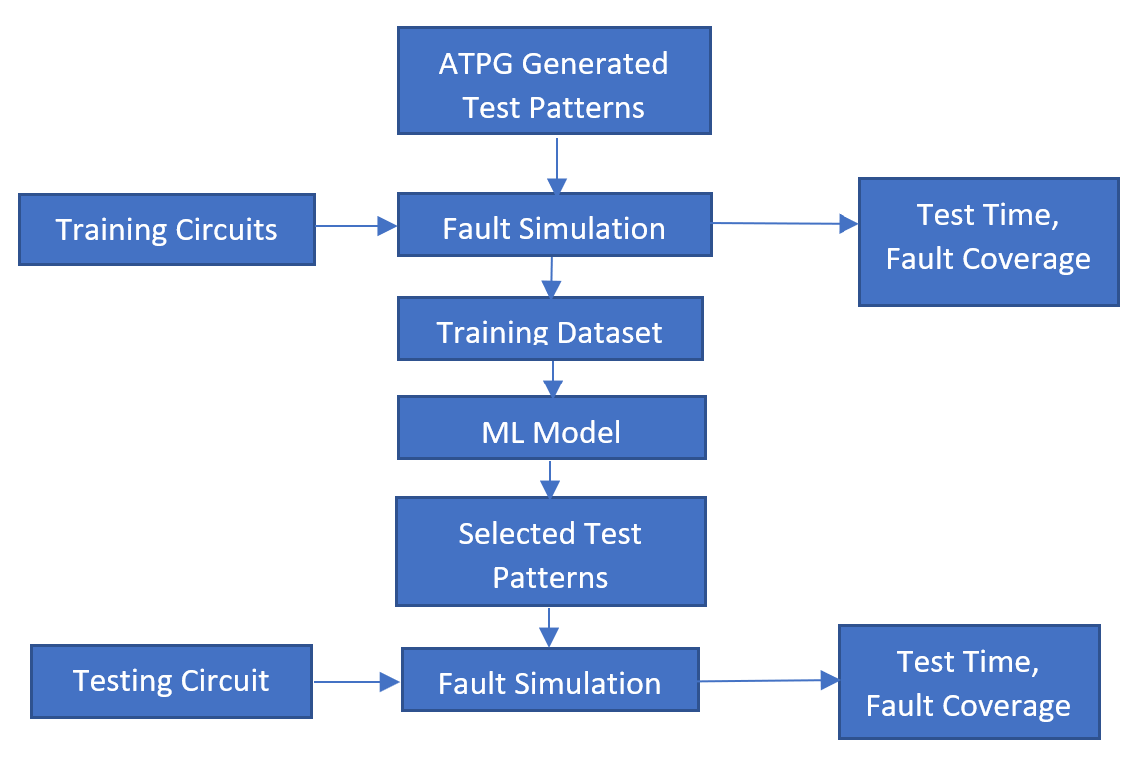
Fig 1: Proposed Methodolgy

A. Test pattern generation (dataset creation)
In our experiment of test pattern generation, the faults that are injected to the ISCAS benchmark circuits are inputs and the test patterns produced from the ATALANTA tool is the outputs. Before going to the models, we have used it is important to understand how ATALANTA helps us in getting the valid test patterns that could detect a fault. To test the feasibility of the ML algorithms in handling bigger circuits, it is important to create a huge training data. This in turn could be achieved by automation and randomization of fault injection.
ATALANTA is an automatic test pattern generator which uses a fanout- oriented test pattern generation algorithm. Here the algorithm is used for detecting the stuck at 0 and 1 faults using a single fault propagation for its fault simulation. It reduces the complexity of producing test patterns for bigger circuits by avoiding the conjunction form of the benchmark circuit. The ATALANTA tool produces data in form of test patterns along with the faults it could detect, and the output produced when that test pattern is employed to the circuit.
We are taking the netlist of the circuit and finding out the nodes with stuck at faults. Now we are creating the fault list from these nodes which has the possibility of having a stuck at fault. With this fault list we are using ATALANTA tool to find out the test patterns which will detect those faults. Now we are creating the dataset from using the test patterns and the faults that they are detecting, with test patterns as the test features and the faults as the rows, with the data being the if the corresponding fault is detected by the test pattern or not. Table 1 shows an example of a dataset.

Test patterns | F1 | F2 | F3 | F4
000 | 1 | 0 | 0 | 0
001 | 0 | 0 | 0 | 1
010 | 1 | 0 | 1 | 0
011 | 0 | 0 | 0 | 0
100 | 1 | 0 | 1 | 0
101 | 0 | 1 | 0 | 1
110 | 1 | 0 | 0 | 1
111 | 1 | 0 | 1 | 0
Table 1: Dataset example

B. Different supervised learning classifiers employed.
Before concluding whether a particular model is perfect in reducing the test volume or not, it needs to be compared on various parameters like the volume of test reduction, fault coverage, test time, it's optimality ratio. Based on these values, the user must need to make a sound decision on employing a particular algorithm based on the user’s requirement. The algorithms we have implemented in our experiment are as follows: KNN, mRMR, LDA, SVM and two more algorithms.

C. Example
In this section, we will apply our methodology for a simple circuit like C17 of ISCAS’85 benchmark circuits to better understand of our methodology. For accessing ATALANTA, it is necessary for the circuit to be in bench form. So, we take C17.bench (which has 6 NAND gates) and assume there’s a stuck at fault in the nets. This way multiple combination of stuck at faults can be introduced. And if the circuit size gets bigger, imagine the possibility of faults a circuit can have. So instead of applying all possible test patterns to every circuit, we firstly create a model which determines the total possible nodes at which a fault can be injected in a circuit.

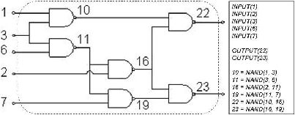
Fig 2: A simple benchmark circuit

With this, randomly we inject stuck-at-0 and stuck-at-1 fault in nodes of the benchmark circuit and generate a fault file. This fault file along with the benchmark circuit is given to the ATALANTA software. Hence, ATALANTA helps us in generating our test patterns that detect these faults. From this list of test patterns, we generate a dataset using pandas where the test patterns are considered as the test features in the columns and the fault list as the rows, with the data being whether the test pattern will detect a fault or not.
This dataset is applied to different algorithms, which gives a reduced set of test patterns

D. Fault Simulation
Now with the reordered test patterns we will simulate the testing with 5 different sets of circuits for which the faults are injected randomly. The test time and the test escape are calculated. For a ATPG tool the testing time(m) of each test pattern is same, so we can use this to calculate the test time by simply calculating the number of test patterns used in the testing process and multiply it with m.
Since we know all the fault instances, we can also calculate the test escape for the for each subset from the fault simulation.
- RESULTS
Determining the optimal parameter value is done for achieving higher prediction accuracy for a model. To achieve this, the ratio of training data and testing data must be optimal. To ensure that the training data set is varied enough and provides comprehensive coverage of the overall dataset, it is selected randomly from different subsets each time. The test data set is then created using the remaining sampled data.
To determine what ratio of training to testing data provides the best results, several ratios are tested: 1:9, 2:8, 3:7, 4:6, 5:5, 6:4, 7:3, 8:2 and 9:1. To get an accurate comparison for these ratios ten repetitions are done and ML algorithm is used each time.
The results obtained from these tests indicate that as we increase the size of our training set while maintaining a fixed test set size; we obtain a smaller value for MSE for test data which indicates better learning performance. In machine learning parlance; lower values of MSE represent better outcomes in terms of learning performance.
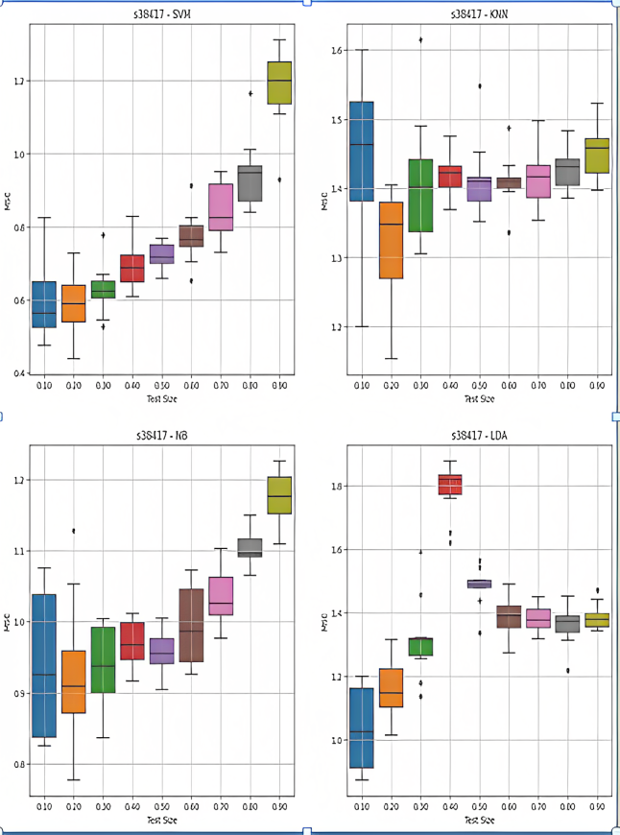
Fig 3: MSE for S38417 circuit

The objective of the adaptive test is to determine, based on the requirements, the optimal trade-off between test duration and test escape. Figures below illustrate the test time required in comparison to the test escape rate based on various proportions of test items.
In the investigation, approximately fourty percent of items were retained when test escape rate was restricted, and test time was reduced.
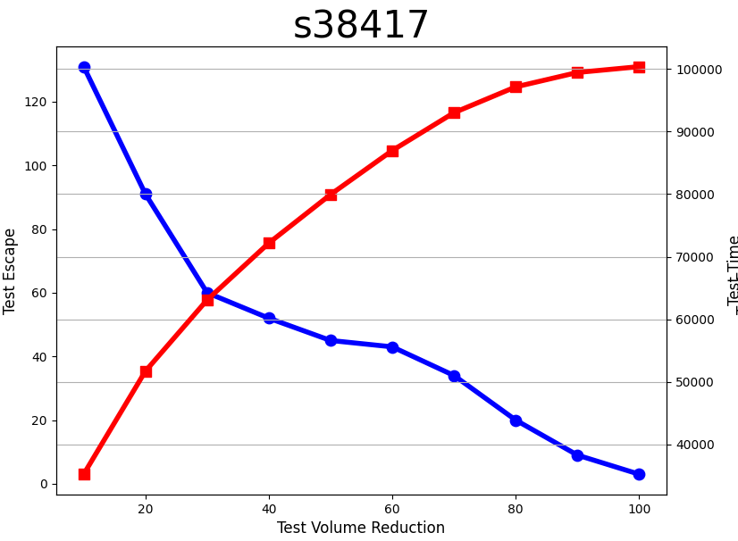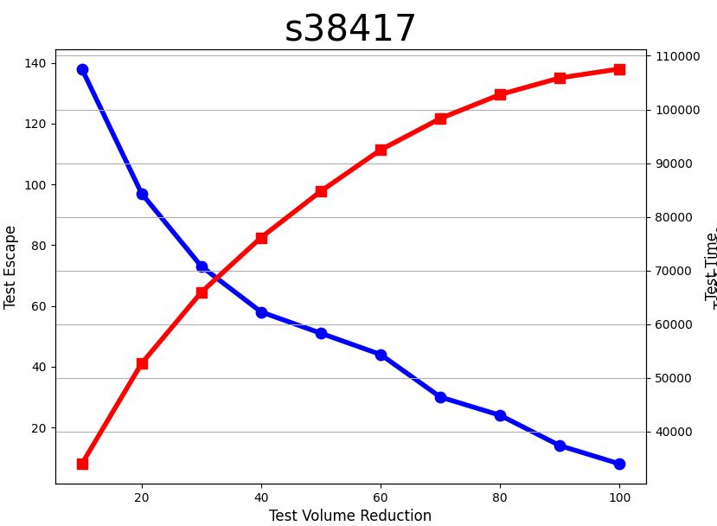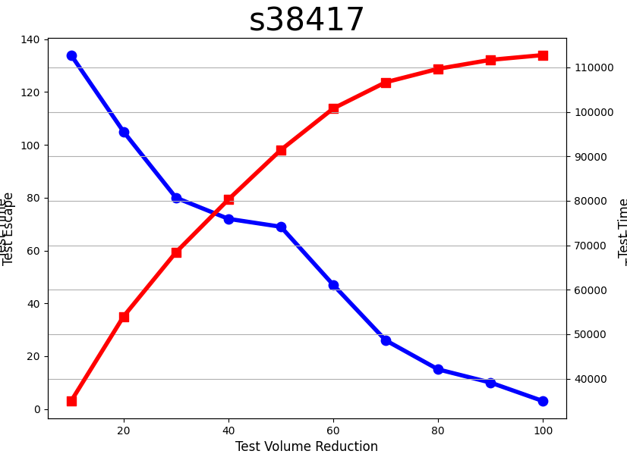
SVM LDA Naive Bayes
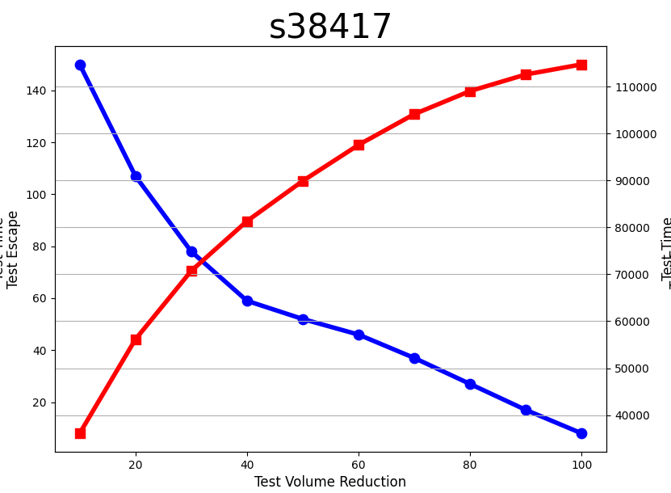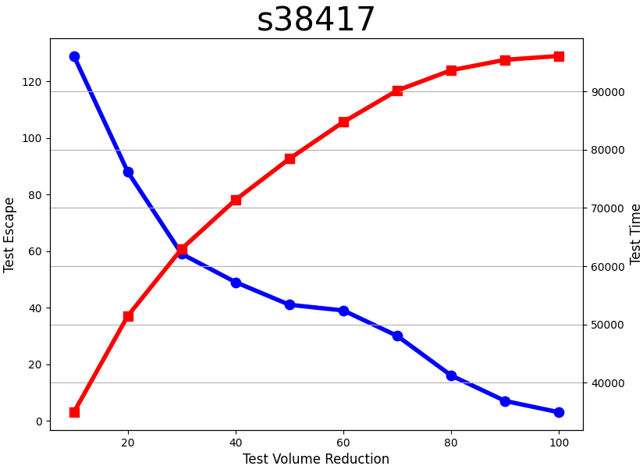
KNN mRMR
Fig 4: Test time and test escape trade-off for S38417

Almost for all circuits and the algorithms the trade-off point is optimal at almost 40 percent. Moreover, 1:9 training: testing ratio of dataset is considered. Also, the accuracy of each model for classifying different set of test pattern is also calculated.

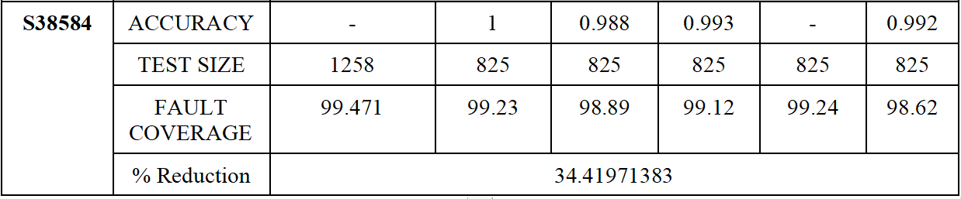
Table 2: Accuracy and fault coverage comparison

BENCH MARK | PARAMETERS | TRADITIO-NAL | SVM | KNN | LDA | MRMR | NB
S713 | ACCURACY | - | 0.666 | 0.76 | 0.714 | - | 0.72
S713 | TEST SIZE | 102 | 72 | 72 | 72 | 72 | 72
S713 | FAULT COVERAGE | 93.46 | 91.874 | 91.412 | 91.124 | 92.241 | 90.24
S713 | % Reduction | 29.41176471
S1196 | ACCURACY | - | 0.93 | 0.804 | 0.713 | - | 0.64
S1196 | TEST SIZE | 230 | 150 | 150 | 150 | 150 | 150
S1196 | FAULT COVERAGE | 100 | 98.552 | 97.913 | 97.752 | 98.542 | 96.911
S1196 | % Reduction | 34.7826087
S5378 | ACCURACY | - | 0.86 | 0.571 | 0.762 | - | 0.62
S5378 | TEST SIZE | 418 | 325 | 325 | 325 | 325 | 325
S5378 | FAULT COVERAGE | 99.121 | 98.754 | 98.471 | 97.424 | 98.544 | 97.202
S5378 | % Reduction | 22.24880383
S13207 | ACCURACY | - | 0.714 | 0.616 | 0.671 | - | 0.837
S13207 | TEST SIZE | 726 | 525 | 525 | 525 | 525 | 525
S13207 | FAULT COVERAGE | 99.121 | 98.89 | 98.25 | 98.23 | 98.75 | 97.91
S13207 | % Reduction | 27.68595041
S38417 | ACCURACY | - | 0.62 | 0.57 | 0.727 | - | 0.822
S38417 | TEST SIZE | 1591 | 1200 | 1200 | 1200 | 1200 | 1200
S38417 | FAULT COVERAGE | 98.461 | 99.12 | 98.78 | 98.72 | 99.12 | 97.81
S38417 | % Reduction | 24.57573853
S38584 | ACCURACY | - | 1 | 0.988 | 0.993 | - | 0.992
S38584 | TEST SIZE | 1258 | 825 | 825 | 825 | 825 | 825
S38584 | FAULT COVERAGE | 99.471 | 99.23 | 98.89 | 99.12 | 99.24 | 98.62
S38584 | % Reduction | 34.41971383

Table 3: fault coverage, test size and accuracy for ISCAS’89 circuits

From the above table it can be inferred that SVM performs better than other algorithms due to its capability to adapt to non-linear datasets. This is followed by mRMR and then by KNN, LDA and finally by Naive Bayes model. With this results , one can infer the successful implementation of the methodology and usage of various algorithms to reduce the test volume without compromising the fault coverage. Also, when we compare the traditional testing with ML algorithms, we can see a minimum reduction of 22.4% of test pattern with nominal fault coverage in the methodology we proposed.

- CONCLUSION
This paper emphasis on reducing test costs by identifying the most effective test items and making accurate predictions. It only applies test items with higher effectiveness, and the comparison demonstrates that the proposed idea significantly reduces test time without evidently increasing the defect rate. In addition, the selection method can be swiftly computed and updated based on statistical data.
When it comes to actual application, however, the implementation of machine learning algorithms requires additional time and skill. The method's associated costs and dangers cannot be disregarded. In the future, we will attempt to apply the method to actual industrial experiments in order to conduct additional research. Moreover, the accuracy of the ML models could be verified more properly by increasing the amount of faults to be injected in a circuit. And look at how the ML model classifies a fault and reduces the test pattern. At the same time, we will address the issue of utilising online data, which can update the model in real time to enhance prediction accuracy.

References
[1] B. J. Lavanyashree and S. Jamuna, "Design of fault injection technique for VLSI digital circuits," 2017 2nd IEEE International Conference on Recent Trends in Electronics, Information & Communication Technology (RTEICT), Bangalore, India, 2017, pp. 1601-1605.

[2] J. Shaktisinh, J. Popat and R. Patel, "Power reduction techniques used in testing of VLSI circuits," 2015 Annual IEEE India Conference (INDICON), New Delhi, India, 2015, pp. 1-4.

[3] Zhang, L., Mei, J. & Yan, B. A new test set compression scheme for circular scan. J Embedded Systems 2018, 1 (2018).

[4] Fang, Chenlei & Huang, Qicheng & Blanton, R.D.. (2020). Adaptive Test Pattern Reordering for Diagnosis using k-Nearest Neighbors. pp.59-64.

[5] José M. Solana, Reducing test application time, test data volume and test power through Virtual Chain Partition, Integration, Volume 42, Issue 3,2009, Pages 385-399, ISSN 0167-9260, https://doi.org/10.1016/j.vlsi.2008.12.001

[6] Liang, H.; Wan, J.; Song, T.; Hou, W. Identifying the Optimal Subsets of Test Items through Adaptive Test for Cost Reduction of ICs. Electronics 2021, 10, 680.

[7] Tai Song, Zhengfeng Huang, Aibin Yan, Machine learning classification algorithm for VLSI test cost reduction, Integration, Volume 87, 2022, pp.40 48.

[8] C. N. Kumar, A. Madhumitha, N. S. Preetam, P. V. Gupta and J. P. Anita, "Fault Diagnosis Using Automatic Test Pattern Generation and Test Power Reduction Technique for VLSI Circuits," 2019 3rd International Conference on Trends in Electronics and Informatics (ICOEI), Tirunelveli, India, 2019, pp. 412-417.

[9] Sinduja V, S. Raghav and Anita J P, "Efficient don't-care filling method to achieve reduction in test power," 2015 International Conference on Advances in Computing, Communications and Informatics (ICACCI), Kochi, India, 2015, pp. 478-482.

[10] A. Asokan and J. P. Anita, "Multistage test data compression technique for VLSI circuits," 2016 International Conference on Advanced Communication Control and Computing Technologies (ICACCCT), Ramanathapuram, India, 2016, pp. 65-68.

[11] K. Abinandhan, K. Gurucharan, M. Purnima, S. Sai Vandana and J. P. Anita, "Application Specific Testing for VLSI Benchmark Circuits," 2022 7th International Conference on Communication and Electronics Systems (ICCES), Coimbatore, India, 2022, pp. 178-184.

[12] Veena, V., Prabhu, E., Mohan, N, “Improved test coverage by observation point insertion for fault coverage analysis”, Proceedings of the International Conference on Trends in Electronics and Informatics, ICOEI 2019, pp. 174-178.

[13] S. Letchumanan, T. H. H. Tan, Y. P. Gan and S. L. Wong, &quot;Adaptive test method on production
system-level testing (SLT) to optimize test cost, resources and defect parts per million (DPPM),&quot;
2018 International Symposium on VLSI Design, Automation and Test (VLSI-DAT), Hsinchu,
Taiwan, 2018, pp. 1-3.

[14] Z. Pan, J. Sheldon and P. Mishra, &quot;Test Generation using Reinforcement Learning for Delay-based
Side-Channel Analysis,&quot; 2020 IEEE/ACM International Conference On Computer Aided Design
(ICCAD), San Diego, CA, USA, 2020, pp. 1-7.

[15] L. Gaber, A. I. Hussein, and M. Moness, ‘Improved Automatic Correction for Digital VLSI Circuits’,
in 2019 31st International Conference on Microelectronics (ICM), 2019, pp. 18–22.

[16] S. Roy, S. K. Millican, and V. D. Agrawal, ‘Machine Intelligence for Efficient Test Pattern Generation’, in 2020 IEEE International Test Conference (ITC), 2020, pp. 1–5.

[17] C. Xue and R. D. Blanton, ‘Test-set reordering for improving diagnosability’, in 2017 IEEE 35th VLSI Test Symposium (VTS), 2017, pp. 1–6.

[18] T. Long, H. Wang, and B. Long, ‘Test generation algorithm for analog systems based on support vector machine’, Signal, Image and Video Processing, vol. 5, no. 4, pp. 527–533, Nov. 2011

[19] L. Malihi and R. Malihi, ‘Single stuck-at-faults detection using test generation vector and deep stacked-sparse-autoencoder’, SN Applied Sciences, vol. 2, no. 10, p. 1715, Sep. 2020.

[20] A. Feldman, G. Provan, and A. Gemund, ‘A Model-Based Active Testing Approach to Sequential Diagnosis’, Journal of Artificial Intelligence Research, vol. 39, pp. 301–334, 09 2010.

